Dividing Polynomials
Write your name, the class, the date, the section and the project name at the top of a blank sheet of graph paper. You may work in pairs or teams if you like.

- Divide the polynomials using long division
  - $(4x^{4}+14x^{3}+9x)÷(x^{2}+3x)$
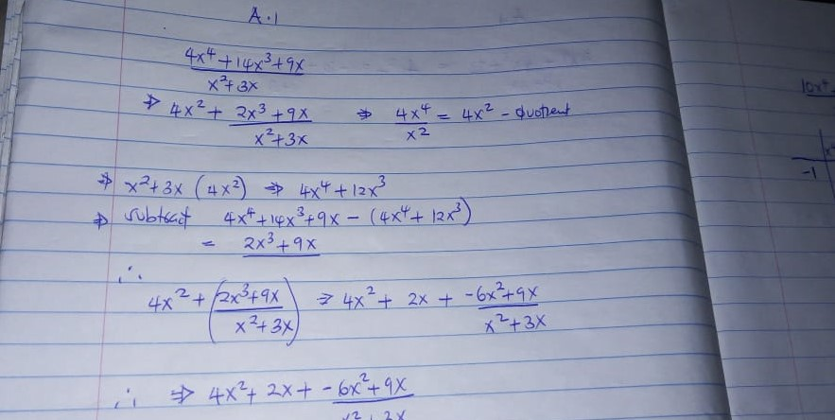
  - $(2x^{4}+2x^{3}-10x-9)÷(x^{3}+x^{2}-5)$

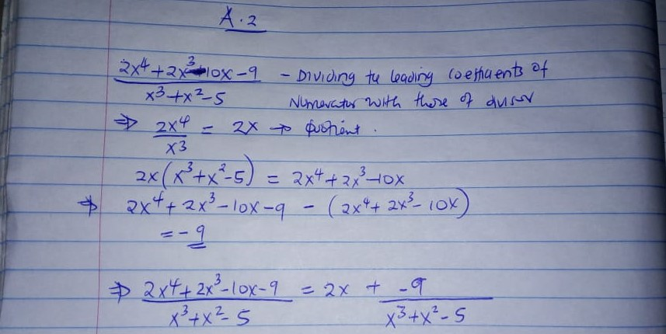

- Divide the polynomials using synthetic division and write the multiplication equation that results

  - $(10x^{4}+5x^{3}+4x^{2}-9)÷(x+1)$
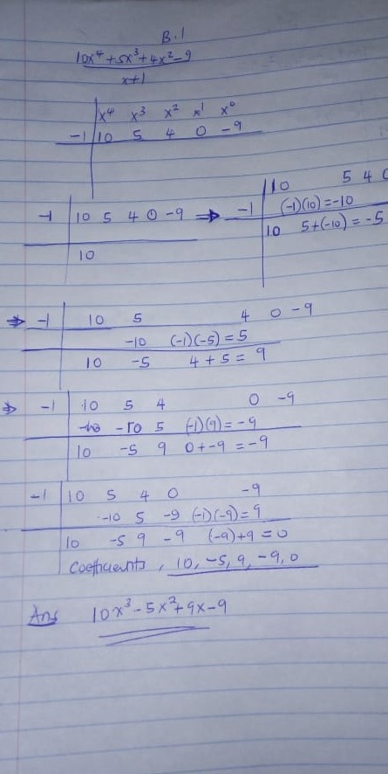

  - $(x^{3}-5x^{2}-2x+24)÷(x+2)$

